**AGIcam Image Data Processing**

Agricultural IOT camera system



**AgroDevs**

Abhilash Ambati

Zachary Hall

Jordan Muehlbauer

**Table of Contents**

1. **Introduction 2**
2. **Background and Related Work 2-3**
3. **Project Overview 3-4**
4. **Client and Stakeholder Identification and Preferences 4**
5. **System Requirements 4-8  
   1. Use cases  
   2. Functional Requirements   
   3. Non-Functional Requirements**
6. **Architecture Design 8-12  
   1. Overview   
   2. Subsystem Decomposition  
    2.1 Subsystem Name**
7. **System Evolution 12**
8. **Glossary 12-15**
9. **References 15**

# **I.** **Introduction**

Originating from Pullman WA, Washington State University Phenomics Lab developed an Auridino-based IOT camera system known as AGIcam. This camera is tasked with monitoring crop conditions in remote fields. AgroDevs is a team of 3 WSU computer science students tasked with evaluating and improving data transfer and compression as well as evaluating edge computing and minimal power consumption solutions. Improving these aspects will allow for AGIcam to provide a better user experience and reduce overhead for farms using the sensor. Our team is working directly with Dr. Sankaran to meet these goals and advance the prosperity of AGIcam.

This project intends to allow farmers to remotely monitor their crops. It will achieve this by enabling the farmer to record data at user-specified intervals from sensors scattered throughout their farm. The sensors will then send the data to a central control hub. This hub then stores the data and allows the farmer to access the data. The idea behind this is to save farm resources by minimizing time spent by the farmer in the field.

# **II.** **Background and Related Work**

Plant phenotyping is the process of assessing the “growth, development, tolerance, resistance, architecture, physiology, ecology, yield, and the basic measurement of individual quantitative parameters” [1] of plant life. It is key in farmers’ plant selection process as well as the research surrounding sustainable farming. Researchers are currently trying to develop standardization for large datasets of plant phenotyping [2].

Through phenotyping, the project’s goal was to “allow plant breeders to monitor multiple trials for timely crop management” [3]. This was done by creating a low-cost sensor system with dual cameras that collected data at user-defined intervals. This system could be used to both monitor current crops and test how well certain crops grow in certain temporal weather environments (i.e. this wheat strain did best during this weather pattern). This combination would allow for better wheat strain selection and current crop management both leading to increased plant yield.

Systems operations for the sensor system were programmed using a Linux-based operating system Raspbain Buster. These systems were commanded using Python 3 (Python Core Team 2015) [3]. The Python library Picamera was key in programming the cameras to capture images at user-defined intervals. The cameras would automatically adjust white balance, image resolution, frame rate, exposure mode, and shutter speed associated with lighting conditions. This allowed for two images to be captured (one RGD and one NoIR from the respective cameras), combined into one side-by-side image, and stored on an SD card. A commonly used, robust weather system was used to collect weather data.

After data was collected, image processing took place. There was four main steps [3]:

1. Image separation (separating the RGB and NoIR images)
2. Vegetation index calculation (NoIR image used for computation)
3. Plot segmentation (Regions of interests created)
4. Data extraction (NDVI value was calculated from the region of interests)

Once the NDVI value was obtained, it was added to a CSV file with the following format [3]:

* Date: date of data acquisition
* Time: time of data acquisition
* Mean: mean of NDVI value
* Median: median of NDVI value
* STD: standard deviation of NDVI value
* Maximum: maximum of NDVI value
* QT75: average of the highest 25% of NDVI value
* QT90: average of the highest 10% of NDVI value
* Plot: plot number on the field trial

From here, image analysis was done using Python 3 and mostly OpenCV library. The system can be used to find different vegetation indices representing canopy vigor, crop health, growth rate, and different stages of crop growth and development [3].

Related work that may be beneficial to the project is the concept of edge computing, data transfer efficiency, and eventually machine learning algorithms. Edge computing is a method of improving data transfer efficiency by doing a lot of the processing locally before burdening the network with unnecessary data transfer [4].

The provided recourse [3] may be outdated compared to where the project currently is. The current state of data transfer is unknown, but we believe it has evolved past physically transferring SD cards.

# **III.** **Project Overview**

Currently, the client wants us to improve data transfer algorithms to improve the battery life of the sensor. Our main goal is to decrease power consumption as much as possible. Sensor battery life is currently limited to five days [3] and the data transfer process can be optimized. To do this, we will be exploring edge computing and data transfer algorithms. Until we have a better understanding of the current system, and what options the client has already explored, it is difficult to understand how this will be done beyond speculation. Eventually, once this part of the project is optimized, we will have the option of improving image processing possibly using machine learning.

The data transfer process will eventually be updated from physically transferring SD cards to a network-based system. Edge computing would then allow for improved data transfer efficiency. This could involve having the sensor nodes take care of the image processing step, or having the sensor nodes transfer their data to an intermediate node that takes care of image processing and combining data into a CSV file which is transferred to the centralized hub.

Outside of edge computing other efficient data transfer algorithms will be explored once current hardware is better understood.

Once the data transfer process is optimized and finalized, we will have the option of exploring image processing using machine learning. While what we will be able to contribute in the given time scale will be limited, we hope to leave the client with at least a minimal machine-learning model that can be used as a skeleton for future image-processing work.

# **IV.** **Client and Stakeholder Identification and Preferences**

Washington State University Phenomics lab developed an Aurdino-based IOT camera system known as AGIcam that monitors crop conditions in remote fields. The main goal of AgroDevs is to improve the functionality of the system that is currently being used. In the AGIcam, we will be working on improving the efficiency of the system such as reducing the power usage of the microcontroller and the power usage during a data transfer and making sure the data transfer efficiency can be associated with data format during edge computing.

The main purpose of the AGIcam is to make sure that the crop conditions are optimal and to make sure we get the most yield possible, by improving these aspects we make sure that AGI cam can provide a better user experience and reduce the damage to sensors.

AGIcam is a federally funded program that targets aspects like food security, crop improvement, and the breeding process.

The AGIcam is currently being tested on Andrew Nelson, Nelson Farm, these farms under the supervision of Sankaran, Sindhuja is being tested with AGIcam, and our improvements will affect the yield and the user interface.

# **V.** **System Requirements Specification**

The client wants us to improve data transfer algorithms in order to improve the battery life of the sensor. Our main goal is to decrease power consumption as much as possible. The system currently uses a Raspberry Pi camera module to capture images in specified intervals for image processing, the module is working properly but it’s not efficient to make it more efficient the team will have to research and decide if they should keep using the Raspberry Pi camera module or change it to Arduino. Addition with these camera modules there are multiple sensors that are being used to keep track of temperature, moisture, and crop health currently the data from these sensors have been processed separately since we have an option to use a centralized unit to process the data from these sensors we have to research if using a centralized unit will help or decide to keep processing the data separately.

The current system is designed to work on larger-scale farms, but there is an issue with this, the current broadband used is not strong enough to receive data after a certain distance, and the team needs to research and decide which broadband will best match and satisfy the desired area. In order to make the system more efficient, the team has to research and find better ways to do Data/image compression-decompression and also come up with better data visualization tools, the current data visualization and Data/image compression/decompression code are in python which is not the best match for the system, the team has to optimization the code and decide which language to optimization the code in.

## **V.1.** **Use Cases**

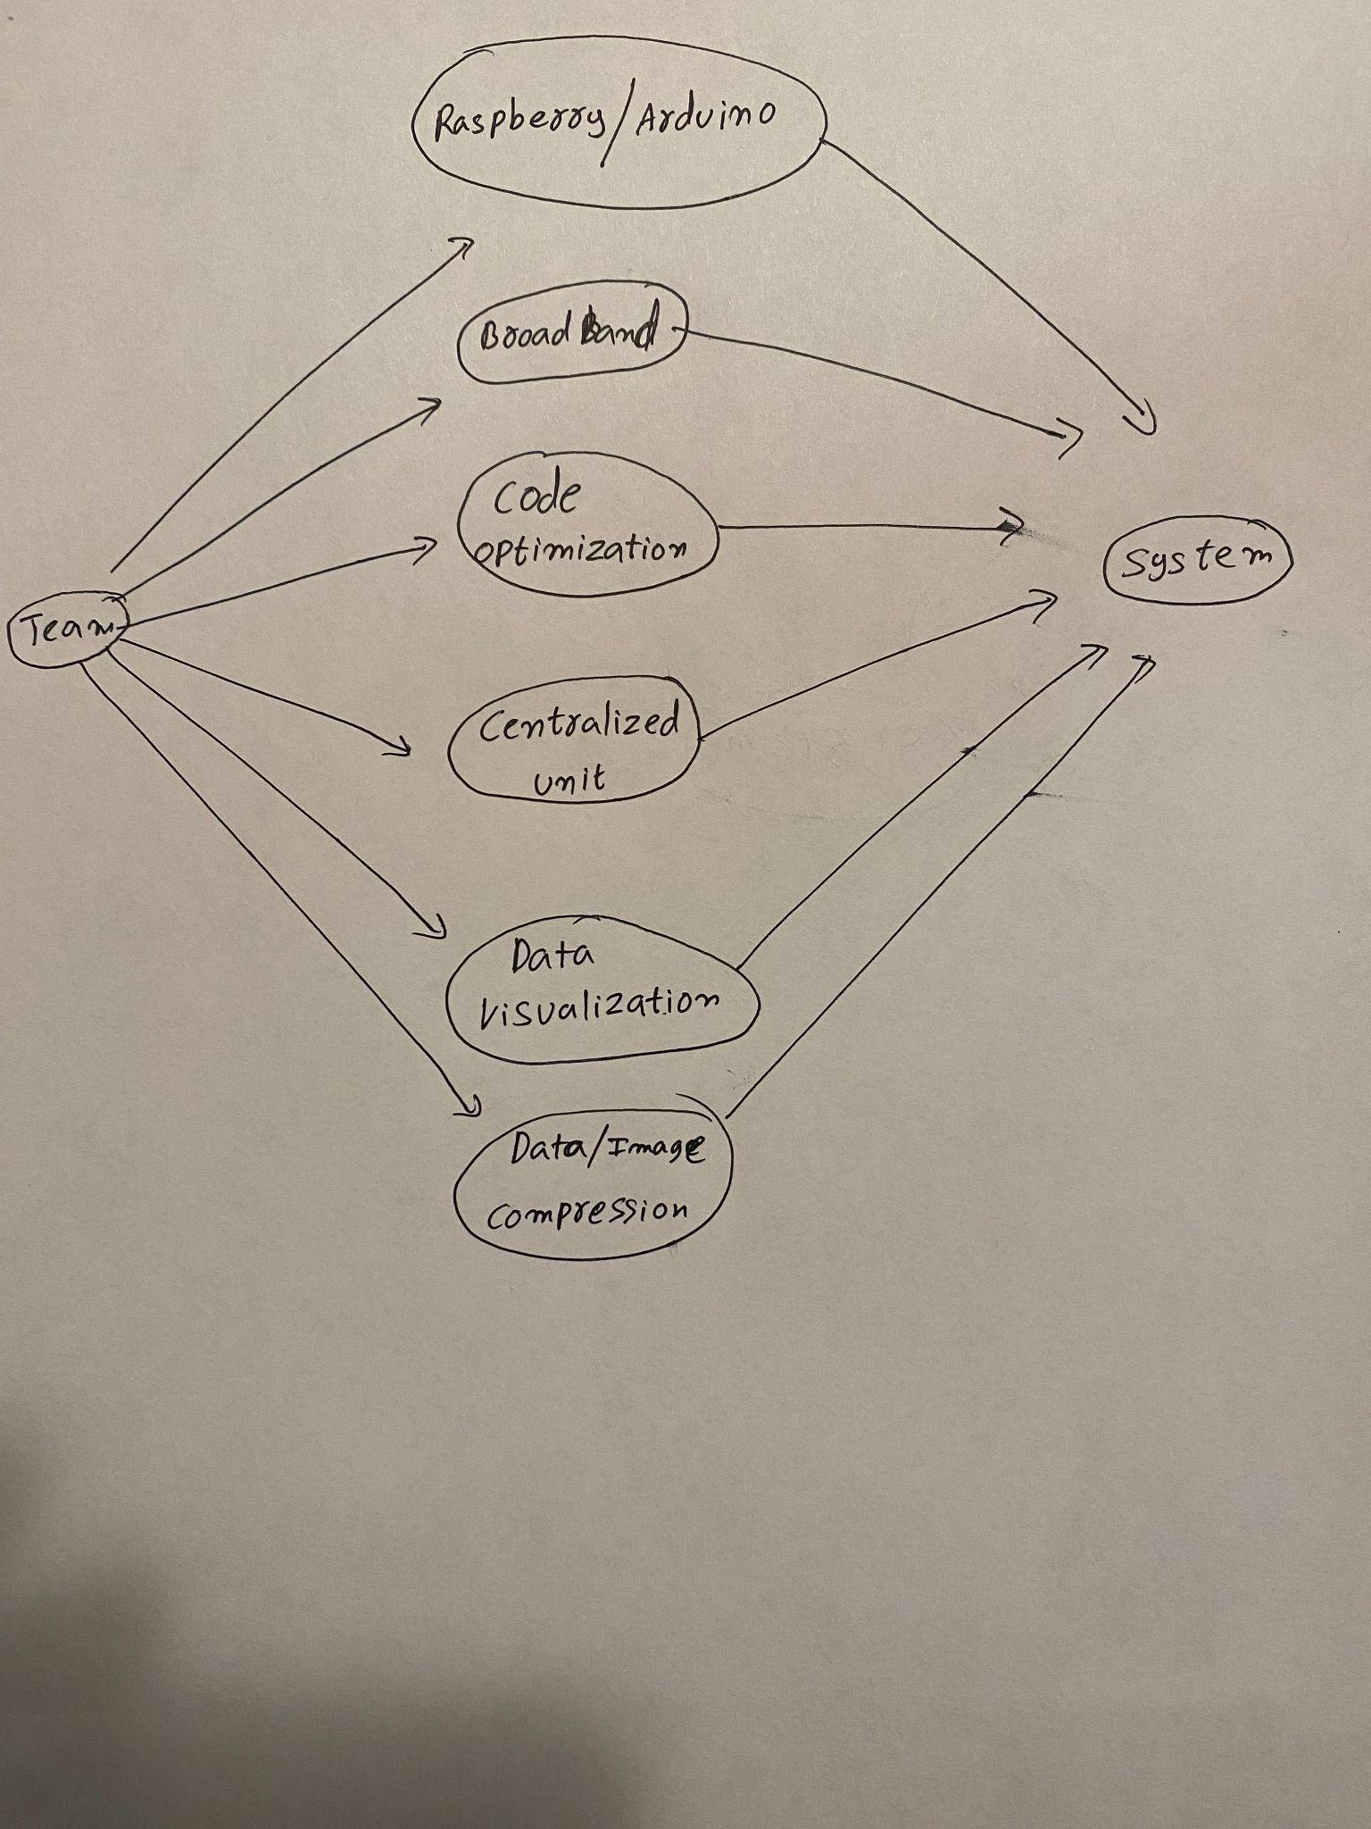

## **V.2.** **Functional Requirements**

Below lists the functional requirements for each of the system's parts. These parts include the sensors’ processor, central hub/user interface, and database.

### **V.2.1.** **Sensors’ Processor**

1. **Take RBG and NoIR pictures**
   1. The processor should be able to take pictures from both cameras, at the same time, at user-specified intervals
   2. Maps to the user being able to collect data
   3. Priority Level: 0
2. **Combine data from different cameras and sensors**
   1. The processor should be able to combine the RBG and NoIR images that were taken at the same time, associate the image with a timestamp, and combine other data taken at the sensor at the same time. This could include weather data.
   2. Maps to the user being able to collect data
   3. Priority Level: 0
3. **Compress the data**
   1. The processor should be able to compress the combined data for it to be sent to the central hub
   2. Maps to the user being able to collect data
   3. Priority Level: 1
4. **Send the data to the central hub**
   1. The processor should be able to send the compressed data to the central hub
   2. Maps to the user being able to collect data
   3. Priority Level: 0

### **V.2.2.** **Central hub/User Interface**

1. **Allow users to request data**
   1. The system should allow users to request data from the database
   2. Maps to the user being able to see data
   3. Priority Level: 0
2. **Display the requested data in a way that is organized and easy to interpret**
   1. The system should display the data in a way that is easy to understand. It should group data by sensor number and timestamp.
   2. Maps to the user being able to see data
   3. Priority Level: 0
3. **Receive data**
   1. The system should be able to receive data from multiple nodes
   2. Maps to the user being able to collect data
   3. Priority Level: 0
4. **Decompress data**
   1. The system should be able to decompress received data
   2. Maps to the user being able to collect data
   3. Priority Level: 1
5. **Store data in the database**
   1. The system should be able to store collected data in a database
   2. Maps to the user being able to collect data
   3. Priority Level: 0
6. **Retrieve requested data**
   1. The system should be able to retrieve data from the database
   2. Maps to the user being able to see data
   3. Priority Level: 0
7. **Set sensor time intervals**
   1. The system should allow the user to adjust the time intervals on a specified sensor, or globally across all sensors
8. Maps to the user being able to collect data
9. Priority Level: 2

### **V.2.2.** **Database**

1. **Store data from sensors**
   1. The database should store the data received from the central hub
   2. Maps to the user being able to collect data
   3. Priority Level: 0
2. **Make data searchable**
   1. The database should be searchable by user-specified queries
   2. Maps to the user being able to see data
   3. Priority Level: 0

## **V.3.** **Non-Functional Requirements**

**Economically Extensible**

Our system needs to drain as little energy as possible to allow users to extend their network of cameras without having high energy overhead. We should aim to use components that provide the best value for their price.

**Easy to configure**

Our system needs to be able to be set up with little to none technical background or experience. Our device should be configurable to fit different scenarios where our out-of-the-box solution might not fit.

**Reliability**

Our system needs to be able to transfer data reliably and detect when there is corruption as well as stay functional with minimal human interaction.

**Maintainable**

This project needs to have a well-documented user guide making it easy to set up. Along with this our codebase for this project must be well documented so that changes are easy to produce.

**Accurate**

We need to provide accurate crop information to our users so they have an accurate idea of the state of their farms. If there are any drastic changes between readings we should be able to analyze this and ensure nothing inaccurate is being reported to users

**Easy-to-use data extraction**

Our system needs to be able to extract data without the need for human interaction. Data should flow to our control system automatically and should not require physical travel to each node for data to be collected.

# **VI.** **Architecture Design**

## **VI.1.** **Overview**

There are three main components to the system. They are the sensor module, the database, and the user interface. The sensor module is responsible for capturing data, formatting the data, and sending it to the database. The database is responsible for storing the data and providing the user interface with fast searchability. Finally, the user interface is responsible for accessing the database and presenting the data to the user in an organized, understandable manner.

We used a modified model view controller design. We did this mainly to decouple the database from both the data collection and user interface allowing for a more modular software design. For example, while we have decided to use a LTE connection for our sensors, the modular design will allow for a change in connection type without having to change data collection.

The following is a very simplified view of the system architecture: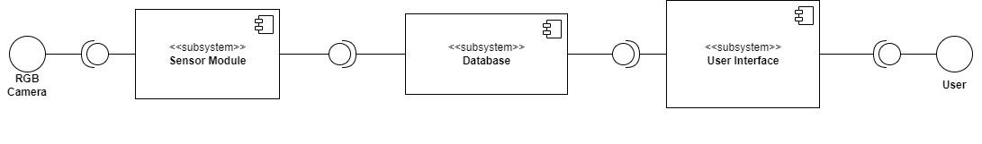

## **VI.2.** **Subsystem Decomposition**

The system will be broken down into three subsystems: sensor module, database, and user interface. The rationale of this is to decrease the amount of time the user must be in the field collecting and evaluating data. All data collection should be completed automatically by the sensor once placed in the field. All evaluation of the data should be done on the user interface which can be accessed from the desktop app.

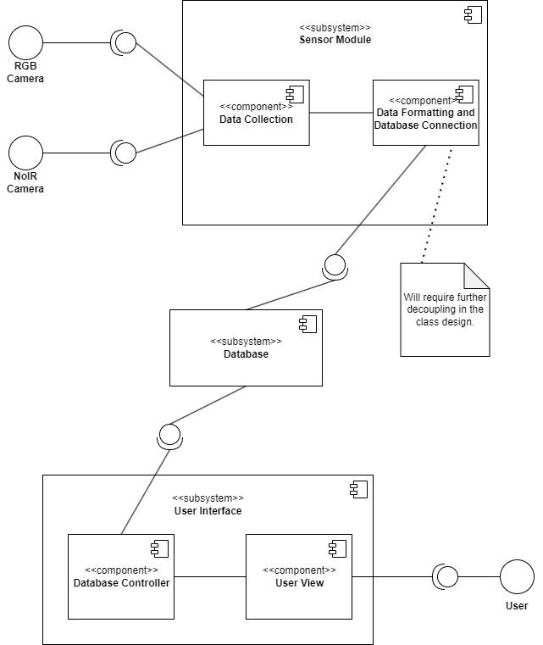

### **VI.1.1.** **Sensor Module**

**a) Description**

The sensor module is responsible for collecting, compressing, and uploading the data into the database. It controls the timing of the cameras and the collection of timestamp data. Within the subsystem, there are two components: data convection module, data formatting, and database connection.

#### **b)** **Concepts and Algorithms Generated**

Breaking the subsystem into two components allows for the decoupling of the connection to the database and data collection. This allows for the connection to the database to be easily changed.

The data formatting can be done within either module, however, we chose the database connection. The reason behind this is that the data collection module only has to be changed when a sensor is added. When a sensor is added each class within the subsystem will have to be changed regardless.

The largest algorithms that will have to be researched is an image compression algorithm and eventually the machine learning algorithm.

#### **c)** **Interface Description**

Services Provided:

1. Timed picture collection.

Service provided to RBG and NoIR cameras

Description: The interface between the cameras and the data collection module will be a timed picture that is taken by the data collection module.

Services Required:

1. Ability to store data

### **VI.1.2.** **Database**

1. **Description**

The database is what will store data collected from the sensor. It will also allow the user to access the data.

1. **Concepts and Algorithms Generated**

Only one table should be required. However, if information about the fields needs to be entered, the design can be adjusted to add another table with the primary key being the field/camera id and other attributes in the same row.

1. **Interface Description**

Services Provided:

1. Ability to store data

Service provided to Sensor Module

Description: It will give the sensor module the ability to store data by allowing it to send insert statements to the database.

2. Ability to access data

Service provided to: User Interface

Description: It will give the user interface access to the data. Most frequent searches will be optimized (indexed). For example, day and time searches will use indexing.

### **VI.1.3.** **User Interface**

1. **Description**

The user interface will display the data and allow the user to request data. This plan may change, but it should display pictures of the crop on a given day/time with a corresponding NDVI.

1. **Concepts and Algorithms Generated**

This subsystem uses a model, view, and controller design pattern and contains the controller and view components represented by the components Database Controller and User view respectively. This is to allow for the decoupling of the database queries and the display the user sees. This allows for one component to be modified with minimal modifying the other.

Currently, we are unsure if the database or the user interface will calculate the NDIV. If we can set up the Database to do so, this would be ideal because it would allow for faster queries involving the NDIV. However, this would most likely mean doing image processing on the sensor module which could decrease battery life.

1. **Interface Description**

Services Provided:

1. Ability to view data

Service provided to User

Description: The user will be able to view the data. There will be buttons on the interface allowing the user to view different datasets.

1. Ability to interpret data

Service provided to User

Description: The data will be organized in a way that the user can easily interpret the data. This will involve having a clear, organized, and appealing user interface.

**VII.** **System Evolution**

Software evolution is important when developing efficient systems. Currently, AGIcam is built on top of Python. Studies have shown that because python is an interpreted language it draws upon a ton of energy compared to low-level compiled languages[9]. This is something to take into account because if we were to switch our current system to a language like C or C++ we would see a significant power reduction. As for our hardware currently, we are building AGIcam with a RaspberryPI which is a microprocessor. Another option we could investigate for reducing our energy footprint would be to switch to a microcontroller that uses less energy but does not contain intensive computational abilities. The hardware change would be substantial and would require lots of research for guaranteeing that our sensors would work with this new board. Our software changes though would provide a much larger and easily implementable change to our solution. Currently, an issue our clients are having with this project is ensuring that the signal can reach remote regions of their farms. Solutions for this issue can range anywhere from using old TV whitespace to implementing a relay-based local network. This is something that we will have to consider going forward as we bring down energy costs because even if we are able to bring costs down, we will still need to be able to extract our data for the client.

# **VIII.** **Glossary**

**C**

**Compiled language** - Programming language where the source code is directly converted into machine code for the processor to execute.[11]

**E**

**Edge computing** – Handling some computation and processing on the client to avoid unnecessary data transfers [4].

**I**

**Interpreted language** - Programming language where the source code is not directly translated by the target machine. The interpreted reads the code and executes it on the target device[11]

**L**

**Local network** - Collection of devices connected together in one physical location.[13]

**M**

**Microprocessor** - A miniature electronic device that contains the arithmetic, logic, and control circuitry necessary to perform the functions of a digital computers central processing unit[10]

**Micro controller** - Chip optimized to control electronic devices. It is used in a single integrated circuit which is dedicated to performing a particular task and executing one specific application[10]

**N**

**Normalized difference vegetation index (NDVI)** – Calculated from near-infrared and visible light reflected by vegetation. Healthy vegetation absorbs most of the visible light and reflects most near-infrared light. Unhealthy vegetation does the opposite [7].

**NoIR image/camera** – A camera without an infrared filter allows for images to be produced in a dark environment [6].

**O**

**OpenCV** – An open-source machine learning software library [8].

**P**

**Plant phenotyping** – The analysis of plant life based on physical/easily observed traits [1].

**Picamera** – Python library that provides a pure Python interface to the Raspberry Pi camera module [5].

**R**

**RGB image/camera** – Visible light spectrum image. An RGB camera produces these images.

**T**

**TV white space** - unused TV channels between the active ones in the VHF and UHF spectrum.[12]

**V**

**Vegetation index (VI)** – A calculated single value that is used to show the amount of plant material in an image [7].

# **IX.** **References**

[1] C. Costa, U. Schurr, F. Loreto, P. Menesatti, and S. Carpentier, “Plant Phenotyping Research Trends, a Science Mapping Approach,” *Front. Plant Sci.*, [Online]. Available: https://www.frontiersin.org/articles/10.3389/fpls.2018.01933/full#:~:text=A%20more%20recent%20and%20comprehensive,complex%20trait%20assessment%20(Li%20et

[2] B. J. Stucky, R. Guralnick, J. Deck, E. G. Denny, K. Bolmgren, and R. Walls, “The Plant Phenology Ontology: A New Informatics Resource for Large-Scale Integration of Plant Phenology Data,” *Front. Plant Sci.*, [Online]. Available: https://www.frontiersin.org/articles/10.3389/fpls.2018.00517/full

[3] W. Sangjan, A. H. Carter, M. O. Pumphrey, V. Jitov, and S. Sankaran, “Development of a Raspberry Pi-Based Sensor System for Automated In-Field Monitoring to Support Crop Breeding Programs,” *Invent.*, vol. 6, no. 2, pp. 42, Jun., 2021. [Online]. Available: https://www.mdpi.com/2411-5134/6/2/42/htm.

[4] S. J. Bigelow. “What is Edge Computing? Everything You Need to Know.” https://www.techtarget.com/searchdatacenter/definition/edge-computing (accessed Sept. 21, 2022).

[5] “Picamera.” https://picamera.readthedocs.io/en/release-1.13/ (accessed Sept. 21, 2022).

[6] “Raspberry Pi Camera Module 2 NoIR.” https://www.raspberrypi.com/products/pi-noir-camera-v2/ (accessed Sept. 21, 2022).

[7] “Measuring Vegetation (NDVI & EVI): Normalized Difference Vegetation Index (NDVI).” https://earthobservatory.nasa.gov/features/MeasuringVegetation/measuring_vegetation_2.php (accessed Sept. 21, 2022).

[8] “OpenCV: About.” https://opencv.org/about/ (accessed Sept. 21, 2022).

[9] D. Cassel, “Which programming languages use the least electricity?,” *The New Stack*, 20-May-2018. [Online]. Available: https://thenewstack.io/which-programming-languages-use-the-least-electricity/. [Accessed: 28-Sep-2022].

[10] L. Williams, “Difference between microprocessor and Microcontroller,” *Guru99*, 29-Aug-2022. [Online]. Available: https://www.guru99.com/difference-between-microprocessor-and-microcontroller.html#:~:text=Microprocessor%20vs%20Microcontroller%3A%20Key%20Difference,used%20in%20an%20embedded%20system. [Accessed: 28-Sep-2022].

[11] “Interpreted vs compiled programming languages: What's the difference?,” *freeCodeCamp.org*, 28-Apr-2021. [Online]. Available: https://www.freecodecamp.org/news/compiled-versus-interpreted-languages/#:~:text=In%20an%20interpreted%20language%2C%20the,reads%20and%20executes%20the%20code. [Accessed: 28-Sep-2022].

[12] “TV white space fact page,” Carlson Wireless Technologies, 11-Jun-2015. [Online]. Available: https://carlsonwireless.com/tv-white-space/. [Accessed: 28-Sep-2022].

[13] “What is a lan? Local Area Network,” *Cisco*, 16-Sep-2022. [Online]. Available: https://www.cisco.com/c/en/us/products/switches/what-is-a-lan-local-area-network.html. [Accessed: 28-Sep-2022].